January | 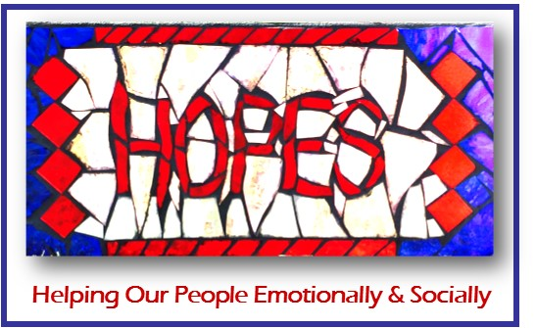  H.O.P.E.S. Drop-In Center  123 Railroad Street  Bedford, PA 15522  814-623-2898  Fax: 814-310-2043
HOURS OF OPERATION  OPEN MONDAY 11:00 -2:30, TUESDAY 11:00 – 3:00, WEDNESDAY 11:00 – 3:00, THURSDAY 11:00 – 2:30, FRIDAY 10:00 -12:00  UNLESS OTHERWISE STATED ON THE CALENDAR | 2025
*Call to reserve a spot for any activity on the calendar* | (814) 623-2898
Sunday | Monday | Tuesday | Wednesday | Thursday | Friday | Saturday
 |  |  | 1 | 2 | 3 | 4
 |  |  | CLOSED   | Celebrate the New Year  With a Sauerkraut Dinner  At Noon  Coloring Pages & Craft | Crossword  Puzzles &  Paper Games | CLOSED
5 | 6 | 7 | 8 | 9 | 10 | 11
CLOSED | Make Snowflakes  and learn about winter | Community Outing in Altoona  Cracker Barrel for lunch  Leave 11:00 am  *Pack or bring money for lunch* | Vo-Tech Cosmetology Day  Leave the DIC @ 12:45 pm  *Bring money for tip & product*  Take the Tree Down | OVR Presentation 11:00 am  Lunch Provided  CSP meeting 1:00 pm  Participation Meeting 2:00 pm | Snowman Craft | CLOSED
12 | 13 | 14 | 15 | 16 | 17 | 18
CLOSED | Clean the Center Day &  Trivia | Altoona Matinee Movie & Lunch  Movie $9.00  Leave 10:30 am  *Pack or bring money for lunch* | Celebrate National Strawberry  Ice Cream Day  Winter Coloring Contest  Peer to Peer Support Group 1:00 pm | Show and Tell Day  &  Create a Collage  *Bring something to show & tell* | Pop-Eye the Sailorman  Day | CLOSED
19 | 20 | 21 | 22 | 23 | 24 | 25
CLOSED | CLOSED   | National Squirrel Day  Watch a Movie  Have some snacks  11:30 am | National Celebration of Life Day  How do you celebrate your life?  Bingo 1:00 pm | Your Safe Haven Boundaries Presentation with Rock Painting  11:15 am  Lunch Provided @ noon | Play Checkers | CLOSED
26 | 27 | 28 | 29 | 30 | 31
CLOSED | Bake Something  Good @ Noon | Winter Craft & Conversation  Learn Something New  Try a Game of Pool | Saint Marks Lutheran Church  Shanksville free give a way day  *Lunch at Snida’s bring money or pack*  Leave 10:30 am | Community Outing  Fisher’s Country Store  Leave @ 11:45 am | Winter Coloring | 